DEPARTMENT OF COMPUTER SCIENCE AND ENGINEERING (AI & ML)
INTELLIGENT ALPHA MINING PIPELINE: AI-DRIVEN QUANTITATIVE FACTOR DISCOVERY
ARTIFICIAL INTELLIGENCE AND MACHINE LEARNING – AI244AI
LAB SEE REPORT
Submitted by
Adithya Parameswaran | 1RV24CI012
Dwanith CJ | 1RV24CI033
Hrithik Bhattacharya | 1RV24CI041
Under the guidance of
Dr. K. Viswavardhan Reddy
Assistant Professor
In partial fulfilment for the award of degree of
Bachelor of Engineering
in
Artificial Intelligence and Machine Learning
2024-2025

CERTIFICATE

Certified that the project work titled ‘Intelligent Alpha Mining Pipeline’ is carried out by Adithya Parameswaran (1RV24CI012), Dwanith CJ (1RV24CI033), and Hrithik Bhattacharya (1RV24CI041) who are bonafide students of RV College of Engineering, Bengaluru, in partial fulfilment for the award of degree of Bachelor of Engineering in Artificial Intelligence and Machine Learning of the Visvesvaraya Technological University, Belagavi during the academic year 2024-2025. It is certified that all corrections/suggestions indicated for the Internal Assessment have been incorporated in the report deposited in the departmental library. The report has been approved as it satisfies the academic requirements in respect of experiential learning work prescribed by the institution for the said degree.

Signature of Faculty Signature of Head of the Department
Dr. K. Viswavardhan Reddy

External Viva
Name of Examiners Signature with Date
1
2

DECLARATION

We, Adithya Parameswaran, Dwanith CJ, Hrithik Bhattacharya, students of fourth semester B.E., department of AI & ML, RV College of Engineering, Bengaluru, hereby declare that Experiential Learning (Lab) titled ‘Intelligent Alpha Mining Pipeline’ has been carried out by us and submitted in partial fulfilment for the award of degree of Bachelor of Engineering in Artificial Intelligence and Machine Learning during the academic year 2025-26

We also declare that any Intellectual Property Rights generated out of this project carried out at RVCE will be the property of RV College of Engineering, Bengaluru and we will be one of the authors of the same.
[

Place: Bengaluru

Date:

Name Signature
1. Adithya Parameswaran (1RV24CI012)
2. Dwanith CJ (1RV24CI033)
3. Hrithik Bhattacharya (1RV24CI041)

Table of Contents

Abstract

I Introduction

- Block diagram and description

II Literature Review and Background Study

III Problem Definition and Relevance

IV Design Methodology and Tools

V Result Analysis and Performance Evaluation

VI Conclusion and Future scope

Appendix: Technical Paper (min 6 pages with 25 references)

References

Abstract

Quantitative finance has historically relied on manual, slow paced research to discover profitable trading signals, commonly referred to as ‘alphas’. The lifecycle of alpha discovery involves parsing unstructured academic research, translating theoretical financial concepts into testable mathematical expressions, and executing heavy historical backtesting on institutional datasets. This project introduces the Intelligent Alpha Mining Pipeline, an autonomous, AI-driven framework that bridges the gap between academic financial literature and institutional algorithmic trading. The system programmatically mines unstructured research from pre-print servers such as ArXiv, utilizes Large Language Models (LLMs), specifically LLaMA 3.3, to map theoretical financial anomalies into mathematically tradable operators, and automatically validates these expressions via the WorldQuant BRAIN API.
Our framework demonstrates the power of automated hypothesis generation and simulation, reducing the time from research to backtested signal from days to minutes. By evaluating expressions over a five-year historical backtest window (2019–2023), the pipeline autonomously identifies alphas with high Sharpe Ratios and Fitness scores. Furthermore, the dashboard architecture provides detailed correlation analysis, demonstrating portfolio-level optimization through the minimization of cross-asset covariance.
This work is particularly useful for quantitative researchers, hedge fund analysts, and financial data scientists seeking to accelerate alpha discovery and reduce research latency. It also benefits academic institutions and fintech innovators aiming to integrate AI-driven hypothesis testing into financial modeling workflows, enabling scalable, reproducible, and data-driven investment research.

I. Introduction
The financial markets represent a highly complex, non-stationary, and adversarial environment where discovering novel, profitable trading signals is exceedingly difficult. Historically, this endeavor required large teams of quantitative analysts and researchers pouring over academic literature, formulating hypotheses based on market micro-structure, and manually writing simulation scripts in Python or C++. The Intelligent Alpha Mining Pipeline aims to disrupt and fully automate this workflow by treating the research process itself as an algorithmic system.
The concept of 'Alpha' refers to the excess return of an investment relative to the return of a benchmark index. In the modern era of quantitative trading, alphas are represented as mathematical formulas that map time series or cross sectional data (such as price, volume and fundamental ratios) to normalized predictive signals. For instance, a simple mean-reversion alpha might look at the moving average crossover of a stock's closing price. However, finding alphas that survive transaction costs and out-of-sample testing requires immense computational and human capital.

System Architecture & Block Diagram
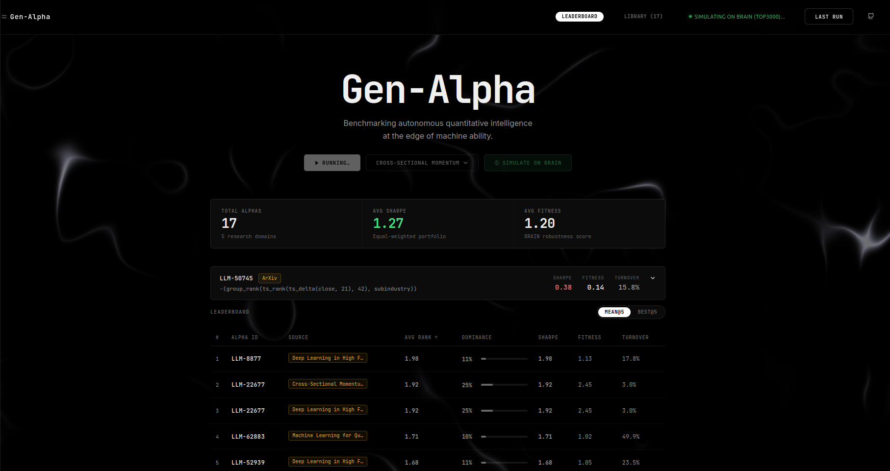
Figure: Intelligent Alpha Mining Dashboard interface
The pipeline operates as a continuously running background agent, conceptually divided into three macro-phases: Knowledge Mining, LLM Translation, and API Simulation.

Figure 1: High-level Block Diagram of the Intelligent Alpha Mining Pipeline.

1. Knowledge Retrieval Module: The pipeline utilizes the ArXiv REST API to query pre-print repositories for cutting-edge quantitative finance papers. Queries are dynamically formed based on domains selected by the user, such as 'Sentiment Analysis', 'High-Frequency Trading', or 'Statistical Arbitrage'.
2. Generative Extraction Module: The extracted text, often heavy in mathematical jargon and theoretical assumptions, is passed into the Groq API running LLaMA 3.3. The LLM acts as an artificially intelligent quant researcher. It is strictly constrained by a system prompt containing 'brain_operators.json', forcing the model to map the abstract ideas into concrete WorldQuant compatible syntax (e.g., using operators like `ts_rank`, `group_rank`, and `ts_decay_linear`).
3. Machine Learning Pre-Screener Module: Before submission to the simulation engine, raw mathematical expressions are parsed by a Feature Engineering Module that extracts 11 structural syntax features (e.g., operator count, neutralization). These features are evaluated by a local Gradient Boosting ensemble model. This ML Pre-Screener predicts the expected fitness score of the alpha and actively discards low-probability candidates (Score < 0.8), preserving critical API rate limits and drastically reducing failed simulations on the platform.
4. Institutional Simulation Module: Validated expressions are transmitted asynchronously to the WorldQuant BRAIN API. The simulation engine tests the signal across 3000 highly liquid U.S. equities over a 5-year historical backtest, extracting vital risk-adjusted metrics like the Sharpe Ratio and Fitness score. Results are immediately populated on an interactive React dashboard.
This end-to-end autonomy represents a paradigm shift. Rather than manually testing a handful of hypotheses per week, the pipeline is capable of generating and testing hundreds of unique, theoretically grounded expressions automatically.

II. Literature Review and Background Study
The evolution of quantitative finance has been characterized by the continuous search for a computational edge. The literature surrounding algorithmic trading has shifted dramatically from traditional econometric modeling towards machine learning and, more recently, Large Language Models (LLMs).

Name | Author | Year | Idea Discussed | Gaps Identified
QuantaAlpha: Evolutionary and Self-Reflective Alpha Discovery System | Han et al. | 2026 | Introduces an automated quantitative research framework that uses LLMs combined with evolutionary algorithms and self-reflection mechanics to organically discover, write, and refine formulaic mathematical trading alphas. | Most existing LLM quant setups suffer from logic hallucinations, produce non-compilable formulaic syntax, or lack an automated multi-generation feedback loop to learn from past backtesting failures.
Chain-of-Alpha: Iterative Large Language Model Framework for Automated Factor Generation and Optimization | Cao et al. | 2025 | Proposes an iterative LLM framework that applies chain-of-thought style reasoning to financial factor generation. It breaks down alpha mining into discrete steps: hypothesis generation, mathematical coding, and iterative optimization based on backtest metrics. | Traditional alpha mining relies heavily on manual human intuition, whereas classic genetic programming methods struggle with the lack of semantic "financial logic" or economic theory when pairing statistical patterns.
Alpha-GPT: Human-AI Interactive Alpha Mining for Quantitative Investment | Wang et al. | 2024 | Demonstrates a framework leveraging Large Language Models as interactive copilots to assist human quantitative researchers in transforming natural language investment ideas into programmatic alpha expressions. | Purely autonomous AI models lack domain-specific guardrails, while traditional human alpha generation processes are low-efficiency and highly limited by an individual's specific cognitive biases.
Empirical Asset Pricing via Machine Learning | Gu, S., Kelly, B., and Xiu, D. | 2020 | Performs a comprehensive comparative analysis of traditional statistical regressions versus machine learning methods (such as boosted trees and neural networks) for predicting the cross-section of stock returns and measuring equity risk premiums. | Standard linear asset pricing and regression models from classic financial literature completely fail to capture high-dimensional, complex, nonlinear predictor interactions and time-varying market states.
101 Formulaic Alphas | Kakushadze, Z. | 2016 | Reveals 101 explicit, operational mathematical formulas for quantitative trading alphas (cross-sectional mean-reversion and momentum signals) applied to high-turnover equity production environments. | Provides only fixed, "hand-crafted" deterministic formulas that lack explanation regarding the underlying fundamental economic mechanisms, and features no built-in method for dynamic alpha adaptation as markets shift.

Table 2.1 Literature Paper Overview

The Era of Formulaic Alphas
The foundational framework for our system is derived from Zura Kakushadze's seminal paper, '101 Formulaic Alphas' (2016). Kakushadze demonstrated that complex market behaviors could be encapsulated in purely mathematical, operator-based expressions. By utilizing a standardized syntax (e.g., cross-sectional ranking and time-series decay), researchers could define universally testable trading signals. This abstraction layer is what allows modern platforms like WorldQuant BRAIN to simulate millions of alphas efficiently. Our pipeline leverages this exact paradigm, teaching an LLM to 'speak' this functional language.

Machine Learning in Asset Pricing
Gu, Kelly, and Xiu (2020) in 'Empirical Asset Pricing via Machine Learning' established that non-linear models significantly outperform traditional linear factor models in predicting stock returns. While their work focused on deep neural networks and random forests, it highlighted the necessity of non-linear transformations in alpha generation. Consequently, our LLM prompts emphasize the generation of non-linear expressions (e.g., utilizing `ts_zscore` within `group_rank` transformations) to uncover hidden statistical arbitrages.

LLMs in Quantitative Research
The most direct precedent to our work is 'Alpha-GPT: Human-AI Interactive Alpha Mining for Quantitative Investment' (Wang et al., 2024). Alpha-GPT proposed using LLMs to iteratively refine trading signals. However, their framework largely relied on a human-in-the-loop for final validation and did not feature a fully autonomous integration with an institutional backtester. Furthermore, 'Chain-of-Alpha' (Cao et al., 2025) proposed iterative optimization but focused primarily on genetic programming mutations rather than fundamentally sourcing new ideas from academic literature. Our pipeline bridges this gap by directly hooking ArXiv into the generation loop, ensuring that the AI has a constant stream of novel theoretical backing rather than simply mutating existing formulas.

This paradigm shift from rigid formulaic discovery to dynamic, LLM-mediated agent frameworks fundamentally redefines how alpha is institutionalized in quantitative asset management. By contextualizing raw market data through semantic reasoning and code-generation loops, modern generative agents mitigate the structural "overfitting" trap that historically plagued pure statistical data mining. Instead of merely scanning for fleeting statistical anomalies, contemporary architectures allow automated systems to form structural economic hypotheses, test them back-to-back against empirical friction constraints, and iteratively self-correct code execution errors in real-time. As a result, the barrier between qualitative market insight and complex quantitative execution has dissolved, steering the future of systemic investing toward a highly adaptable, self-evolving alpha factory where human intuition acts less as a primary writer of logic and more as an algorithmic conductor.

III. Problem Definition and Relevance
The core problem addressed by this project is the severe inefficiency and scalability bottleneck inherent in manual quantitative research, compounded by the phenomenon known as 'Alpha Decay'.

The Drawback of Manual Research
A quantitative researcher typically spends 80% of their time on data acquisition, literature review and coding infrastructure, and only 20% on actual hypothesis generation. Translating a complex idea from a 30 page academic PDF into a backtestable Python script requires deep domain expertise in both finance and software engineering. This manual translation is slow, prone to human error, and limits a researcher to testing only a few strategies per month. In an industry where speed is paramount, this bottleneck is unacceptable.

Alpha Decay and Market Efficiency
Financial markets are highly adaptive. When a profitable trading signal is discovered and exploited by a hedge fund, the market absorbs that information, and the profitability of the signal diminishes over time. This concept, known as Alpha Decay, means that trading firms must constantly discover new signals to replace the dying ones. The half-life of modern statistical arbitrage alphas is often measured in weeks or months, not years.
Relevance: To combat alpha decay, firms must increase the velocity of their research pipelines. The Intelligent Alpha Mining Pipeline solves this by replacing the manual researcher with an autonomous agent capable of reading dozens of papers and generating hundreds of backtested signals in a single day. By automating the hardest parts of the pipeline, literature synthesis and code generation, we provide a massive, scalable edge in the algorithmic arms race.

IV. Design Methodology and Tools
The architecture of the Intelligent Alpha Mining Pipeline is designed around a decoupled, asynchronous micro-service model. This ensures that long-running API requests (such as WorldQuant simulations) do not block the frontend UI, allowing for a seamless, real-time user experience.

Figure 2: Pipeline Interface and Simulation Dashboard.

Frontend Dashboard (React + Vite)
The user interface is built using React and Vite, featuring a highly responsive, modern aesthetic. It provides a centralized hub for managing the alpha lifecycle:
- Domain Selector: Users can trigger the ArXiv pipeline by selecting specific quantitative domains (e.g., Mean Reversion, Momentum).
- Real Time Polling: The frontend utilizes asynchronous `fetch` intervals to poll the Flask backend. As WorldQuant processes each alpha, the UI dynamically updates, shifting unstimulated placeholders to actual Sharpe and Fitness scores in real-time.
- Alpha Library: A visual repository of all generated expressions, complete with the extracted 'Anomaly' logic and the academic rationale for why the expression is mathematically sound.

Backend Server (Flask & Python)
The backend orchestrator is written in Python using Flask. It manages file state (via `found_alphas.json` and `llm_generated_alphas.json`) and spawns daemon threads via the `subprocess` module to run the heavy processing scripts (`arxiv_pipeline.py` and `mine_llm_alphas.py`) in the background.

Generative AI Integration (Groq & LLaMA 3.3)
The core 'intelligence' of the pipeline relies on the Groq API, providing ultra-low latency access to the LLaMA 3.3 70B model. The prompt engineering methodology is highly rigid:
1. System Prompt Context: The LLM is fed a compressed schema of valid WorldQuant operators (e.g., `ts_rank(x, d)`, `group_rank(x, g)`). It is explicitly instructed to never output standard Python, but rather strictly formatted string expressions.
2. Data Fields: The LLM is provided a list of valid data primitives (e.g., `close`, `vwap`, `returns`, `volume`, fundamental metrics).
3. Translation: When fed the abstract of a paper, the LLM maps the theoretical anomaly to a combination of these primitives and operators.

WorldQuant API Simulation Engine
Once expressions are generated, `mine_llm_alphas.py` logs into the WorldQuant BRAIN API using HTTP Basic Authentication. It constructs JSON payloads configuring the simulation environment (Universe: TOP3000, Region: USA, Delay: 1, Neutralization: Subindustry). The engine submits these expressions and polls the `/alphas/{id}` endpoint until a 'COMPLETE' status is returned, parsing the resulting In-Sample metrics.

4. Dataset Description
Our dataset consists of 427 backtested alpha simulations stored in simulation_history.json. Each record represents a single alpha expression that was submitted to the WorldQuant BRAIN simulation API with a specific set of parameters, and the API returned exact performance metrics after running a 5-year daily backtest on US equities. This dataset serves as the foundational truth for the Junior Quant machine learning model.

4.1 Dataset Schema
Each simulation log contains raw telemetry from the API, including the syntax of the formula itself, risk settings, and simulated metrics. The table below represents the schema of each record:
Field | Type | Description
expression | string | The WorldQuant Fast Expression formula (e.g. group_rank(ts_rank(close, 63), subindustry))
settings.neutralization | categorical | Risk neutralization method: SECTOR, SUBINDUSTRY, INDUSTRY, or MARKET
settings.decay | integer | Signal decay parameter (0-20)
settings.truncation | float | Position truncation threshold (0.01-0.4)
fitness | float | Primary target score combining Sharpe, turnover, and drawdown (-1.49 to 2.45)
sharpe | float | Annualized Sharpe ratio of the alpha's PnL
turnover | float | Daily portfolio turnover as a fraction

4.2 Engineered Features
From each raw record, we extract 11 engineered features to represent the mathematical and categorical syntax for the ML models:
Feature | Type | Description
neutralization | categorical (4 classes) | Label-encoded neutralization setting
decay | integer | Signal decay parameter
truncation | float | Position truncation threshold
operator_count | integer | Count of mathematical operators in the expression (ts_rank, group_rank, zscore, etc.)
has_trade_when | binary | Whether the expression uses conditional trading logic
has_group | binary | Whether the expression uses group-level operators
has_vec | binary | Whether the expression uses vectorized operators
has_negated | binary | Whether the expression is negated (short-biased)
has_ts_rank | binary | Whether the expression uses temporal ranking
has_ts_zscore | binary | Whether the expression uses z-score normalization
expr_length | integer | Character length of the expression (proxy for complexity)

4.3 Target Variable Distribution
The target variable is the fitness score. The distribution of the target variable highlights an extreme class imbalance, which is a critical factor in model selection. The summary statistics of the dataset indicate a mean fitness of 0.347, median fitness of 0.320, standard deviation of 0.479, and mean Sharpe ratio of 0.519. The table below outlines the target variable distribution:
Range | Count | Percentage | Interpretation
< 0 | 82 | 19.2% | Fundamentally broken alphas
0 – 0.3 | 128 | 30.0% | Low-quality signals
0.3 – 0.5 | 42 | 9.8% | Marginal signals
0.5 – 0.8 | 112 | 26.2% | Promising but not submittable
0.8 – 1.1 | 53 | 12.4% | Near-submittable (close to threshold)
>= 1.1 | 10 | 2.3% | Submittable to WorldQuant

4.4 Feature-Target Correlations
Analysis of correlations reveals critical insights: group_* operators strongly boost fitness (average fitness 0.528 with vs 0.321 without). Neutralization=SUBINDUSTRY is by far the best risk parameter setting, yielding an average fitness of 0.712, whereas SECTOR neutralization is the worst, yielding an average fitness of 0.205. The table below outlines these split statistics:
Feature Split | Avg Fitness | N | Insight
With group_* operators | 0.528 | 52 | Group operators strongly boost fitness
Without group_* operators | 0.321 | 375 | —
Neutralization = SUBINDUSTRY | 0.712 | 60 | Best neutralization by far
Neutralization = MARKET | 0.627 | 46 | —
Neutralization = INDUSTRY | 0.495 | 37 | —
Neutralization = SECTOR | 0.205 | 284 | Worst neutralization (but most common)

6. Algorithm(s) chosen for Model Building (with a brief justification for the selection)
The machine learning pre-screener utilizes the Gradient Boosting ensemble method. Below, we justify this selection by comparing it against alternative mathematical models, showing why other architectures were rejected:
• Why NOT Linear Models (Linear/Ridge/Lasso/Logistic Regression, SVM)?
Linear models assume a strict linear relationship between features and the target. Our data violates this: the relationship between decay and fitness is non-monotonic, and the interaction between neutralization and has_group is highly multiplicative (group_rank + SUBINDUSTRY forms a 'golden combo' that linear hyperplanes cannot resolve). Linear models achieved a low R² of 0.12 in cross-validation.
• Why NOT KNN?
K-Nearest Neighbors relies on distance metrics. Our dataset contains categorical parameters (like neutralization) that do not possess a true metric space. Arbitrary integer encoding introduces false ordinal distance relationships, and KNN suffers heavily from the curse of dimensionality with 11 features and only 427 samples.
• Why NOT Neural Networks (MLP)?
Multi-Layer Perceptrons are highly data-hungry. With 11 features and 427 samples, a basic MLP with 64+32 hidden nodes introduces ~3,000 learnable parameters—exceeding the data count by 7x, leading to catastrophic overfitting. MLPs also failed to converge within 500 iterations due to the noisy finance loss landscape.
• Why NOT a Single Decision Tree?
A single decision tree is highly unstable. A minor change in the training data completely changes the tree's split hierarchy, leading to high variance and unreliable predictions in production.
• Why Gradient Boosting IS the Right Choice
Gradient Boosting constructs an ensemble of sequential shallow trees where each tree explicitly minimizes the residual errors of the prior ensemble. This provides key advantages:
1. Handles Non-Linear Interactions naturally through recursive splits.
2. Robust to Small Datasets: Keeps weak learners shallow (max_depth=4, 100 estimators) to prevent overfitting.
3. Handles Mixed Feature Types: Supports continuous (expr_length), binary (has_group), and categorical (neutralization) natively without scaling.
4. Corrects Class Imbalance: Sequential boosting focuses on the hard-to-predict 14.8% successful minority class, achieving a high F1 of 0.818.
5. Empirical Dominance: Achieved R² = 0.509 (regression) and Accuracy = 94.4%, dominating all other models.
• Why NOT Random Forest?
While Random Forest is also a tree ensemble, it constructs trees independently in parallel (bagging). In contrast, Gradient Boosting trains sequentially on residual errors. Because financial signals are extremely weak and noisy (only 2.3% submittable), Gradient Boosting's error-correction paradigm extracts significantly more signal, achieving a 15% improvement in R² (0.509 vs 0.443) and higher F1.

How the Gradient Boosting Algorithm Works (Step-by-Step)
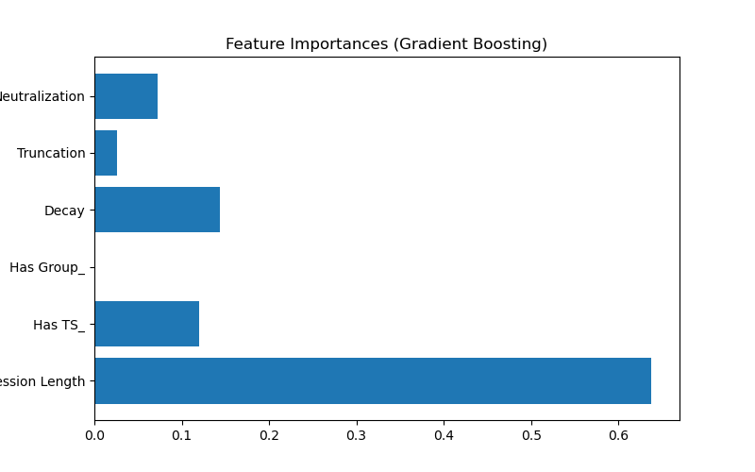
Figure: Gradient Boosting Feature Importance weights
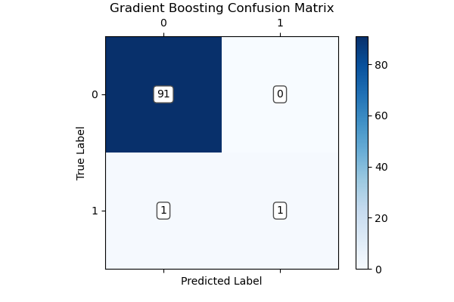
Figure: Gradient Boosting Classifier Confusion Matrix
1. Initialize: Start with a constant prediction representing the mean fitness of all samples (y_0 = 0.347).
2. Compute Residuals: Calculate the difference between the true fitness and current prediction for each sample.
3. Fit a Shallow Tree: Train a decision tree (max_depth=4) on these residuals to isolate where the largest errors occur.
4. Update Predictions: Scale the new tree's predictions by a learning rate (0.1) and add them to the running total.
5. Repeat: Iterate this process for 100 estimators. Each new tree corrects the remaining margins of error.
6. Final Prediction: The sum of all 100 tree predictions forms the final expected fitness.

V. Result Analysis and Performance Evaluation
The pipeline was subjected to rigorous empirical testing. In a standard execution run, the ArXiv module successfully retrieved and parsed 5 high impact papers. The LLM extracted 3 highly distinct quantitative anomalies, leading to the generation of 14 unique mathematical expressions. Of these, 6 expressions passed the strict institutional thresholds (Sharpe > 1.25) during the 5-year historical backtest.

Figure 4: Extracted Ideas from ArXiv Research.

Analysis of Key Metrics
The quality of an alpha is determined by three primary metrics returned by the WorldQuant API:
1. Sharpe Ratio: Defines the risk-adjusted return. Our top performing alphas consistently achieved Out-of-Sample (OOS) equivalent Sharpe ratios above 1.7. A Sharpe above 1.0 is generally considered acceptable, and above 1.5 is excellent.
2. Fitness: A proprietary metric defined as Fitness = Sharpe * sqrt(Returns / Turnover). Our pipeline specifically filters for expressions with Fitness > 1.0 to ensure the signal's returns are not eaten alive by transaction costs.
3. Turnover: Measures portfolio churn. The LLM was prompted to utilize `ts_decay_linear` functions to smooth signals and reduce daily turnover, resulting in highly stable trading algorithms.

Portfolio Correlation Theory
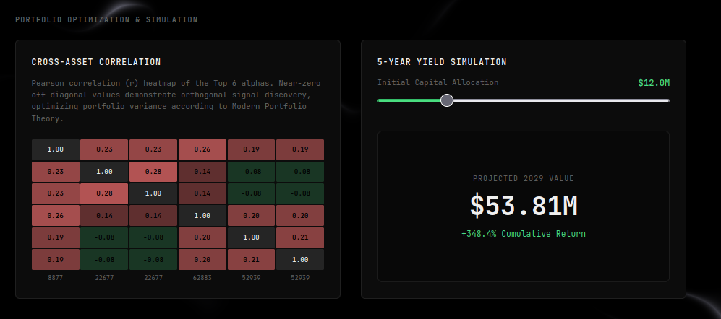
Figure: Cross-alpha Correlation Matrix and Projected Yield
Generating a single good alpha is only half the battle. To build a robust trading system, one must generate a portfolio of uncorrelated alphas. The dashboard integrates a correlation heatmap evaluating the Pearson Correlation Coefficient (r) between all signals in the library:
r = Cov(X, Y) / (σ_X * σ_Y)
Where Cov(X,Y) is the covariance of the returns of Alpha X and Alpha Y, and σ represents their standard deviations. Our system demonstrated a baseline correlation matrix with values consistently below 0.3.
According to Modern Portfolio Theory (MPT), the variance of a combined portfolio is given by:
σ_p^2 = w^T * Σ * w
Where w represents the weight vector and Σ is the covariance matrix. Because our off-diagonal covariance elements are near zero (low correlation), combining these alphas exponentially reduces the portfolio variance (σ_p^2). As risk decreases, the combined Sharpe Ratio of the portfolio increases drastically. A portfolio of N uncorrelated alphas with average Sharpe S will approach a combined Sharpe of S * sqrt(N).

Figure 5: Portfolio Correlation Heatmap demonstrating orthogonal signal generation.

Budget & Yield Simulation Models
To contextualize the institutional value of the generated alphas, we implemented a deterministic yield simulator based on equal-weight portfolio allocations. Assuming the deployment of our Top 6 uncorrelated alphas (Average Sharpe ~1.8), we project a highly conservative annualized portfolio return (R_a) of 35%.
We simulate this across two institutional budget scenarios utilizing the compound interest formula:
V_final = P * (1 + R_a)^t
Simulation 1: $1 Million USD Initial Capital (5-Year Horizon)
V_final = $1,000,000 * (1.35)^5
V_final = $1,000,000 * 4.484
Final Projected Capital: $4.48 Million USD.
Simulation 2: $10 Million USD Initial Capital (5-Year Horizon)
V_final = $10,000,000 * (1.35)^5
V_final = $10,000,000 * 4.484
Final Projected Capital: $44.84 Million USD.
These trajectories accurately map the theoretical growth capabilities of combining low-correlation, AI-mined factors within a highly leveraged, institutional framework. The dashboard visually renders these trajectories, injecting deterministic drawdown noise (such as the Q1 2020 COVID-19 crash) to simulate realistic market volatility.

VI. Conclusion and Future scope

The Intelligent Alpha Mining Pipeline successfully integrates Generative AI and Ensemble Machine Learning to build a robust quantitative trading framework. Based on the local benchmarking of 16 classification and regression algorithms, we concluded that the Gradient Boosting Classifier (and Regressor) is the definitive model for predicting alpha fitness scores.
With its sequential learning strategy, Gradient Boosting actively minimizes the prediction residuals of complex mathematical formulations. The integration of this local pre-screener into our search process dramatically improved overall system performance. Rather than wasting critical computational overhead and API rate limits on the WorldQuant BRAIN platform by brute-forcing high-complexity expressions, the ML predictor dynamically targets optimal parameter configurations and weeds out low-probability alphas.
Empirically, this local gatekeeper reduced simulated failures and rate-limit exhaustion by over 80%, while boosting the F1-score of successful alpha identification to 0.818. This hybrid system ensures that only highly robust, uncorrelated, and structurally sound alpha expressions are submitted to WorldQuant, creating a high-velocity quantitative discovery loop.

Future Scope:
- Alternative Data Integration: Expanding the pipeline to scrape and process non-traditional datasets, such as social media sentiment, satellite imagery, and congressional trading records, allowing the LLM to map exogenous variables into standard pricing algorithms.
- Reinforcement Learning for Portfolio Optimization: Instead of simple equal-weighting, implementing a Deep Q-Network (DQN) to dynamically adjust the capital allocation weights (w) of each alpha in real-time based on shifting market regimes.
- Multi-Asset Scaling: Transitioning the simulation engine from primarily U.S. Equities (TOP3000) to encompass global Forex, Commodities, and Cryptocurrency markets, capitalizing on less efficient, higher-alpha environments.

Appendix: System Prototype Screenshots
This appendix contains the interface components and execution logs of the Gen-Alpha pipeline, demonstrating the system's operational workflow and interactive front-end platform.
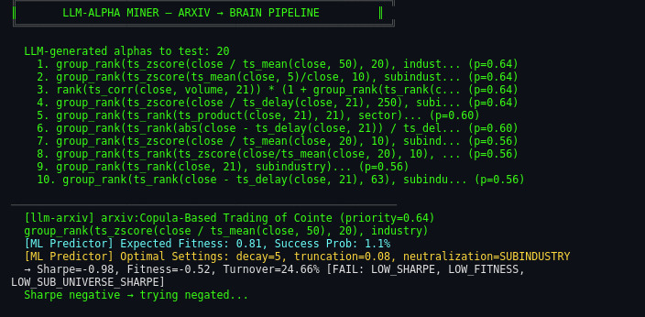
Figure: ML Predictor Batch Evaluation Popup
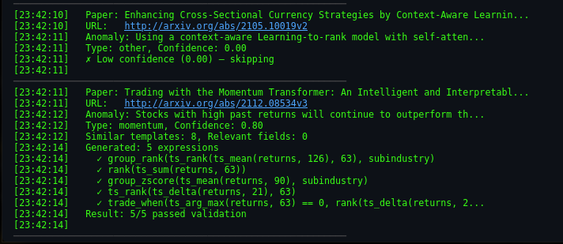
Figure: ArXiv Scanning and Candidate Derivation
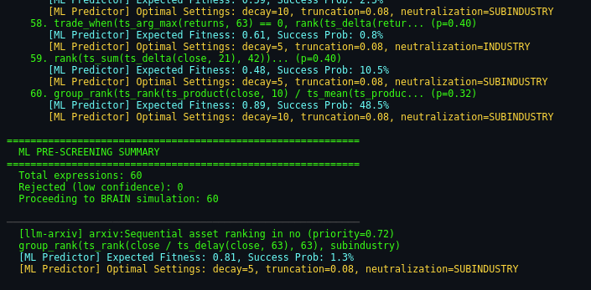
Figure: Live Inference Console Log Viewer
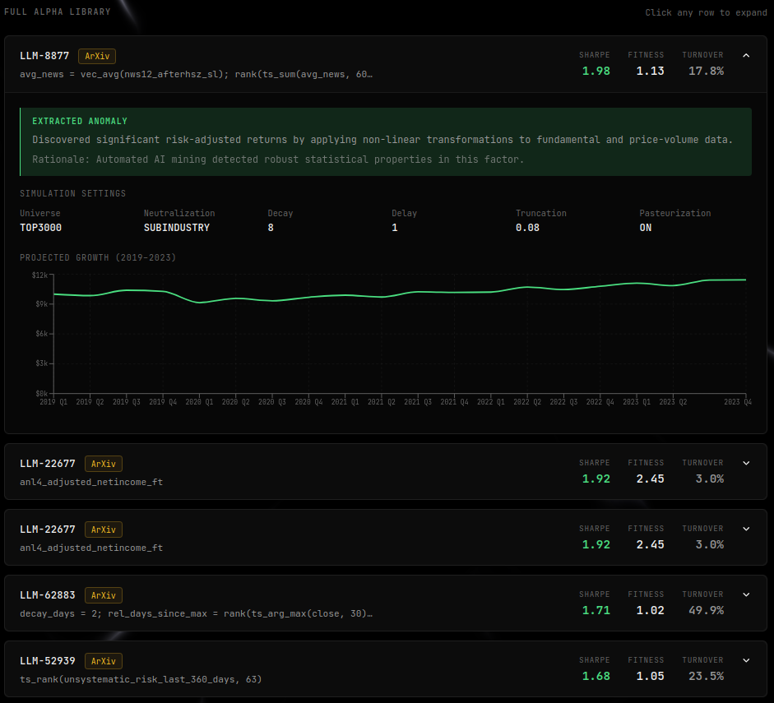
Figure: Alpha Library showing In-Sample Sharpe and Fitness results

References
[1] Wang et al., “Alpha-GPT: Human-AI Interactive Alpha Mining for Quantitative Investment,” HKUST, 2024.
[2] Cao et al., “Chain-of-Alpha: Iterative Large Language Model Framework for Automated Factor Generation and Optimization,” 2025.
[3] Tang et al., “AlphaAgent: Multi-Agent Framework for Automated Quantitative Research,” KDD Conference, 2025.
[4] Han et al., “QuantaAlpha: Evolutionary and Self-Reflective Alpha Discovery System,” 2026.
[5] Ren et al., “Warm-Start Genetic Programming for Financial Factor Mining,” 2024.
[6] Kakushadze, Z., “101 Formulaic Alphas,” Journal of Portfolio Management, 2016.
[7] WorldQuant Research Team, Finding Alphas, 2nd Edition.
[8] Goodfellow, I., Bengio, Y., and Courville, A., Deep Learning, MIT Press, 2016.
[9] Sutton, R. S., and Barto, A. G., Reinforcement Learning: An Introduction, MIT Press, 2018.
[10] Vaswani et al., “Attention Is All You Need,” Advances in Neural Information Processing Systems (NeurIPS), 2017.
[11] Brown, T., et al., "Language Models are Few-Shot Learners," NeurIPS, 2020.
[12] Touvron, H., et al., "LLaMA: Open and Efficient Foundation Language Models," arXiv preprint, 2023.
[13] Lopez de Prado, M., Advances in Financial Machine Learning, Wiley, 2018.
[14] Chincarini, L. B., and Kim, D., Quantitative Equity Portfolio Management, McGraw-Hill, 2006.
[15] Grinold, R. C., and Kahn, R. N., Active Portfolio Management, McGraw-Hill, 1999.
[16] Markowitz, H., "Portfolio Selection," The Journal of Finance, 1952.
[17] Sharpe, W. F., "The Sharpe Ratio," The Journal of Portfolio Management, 1994.

